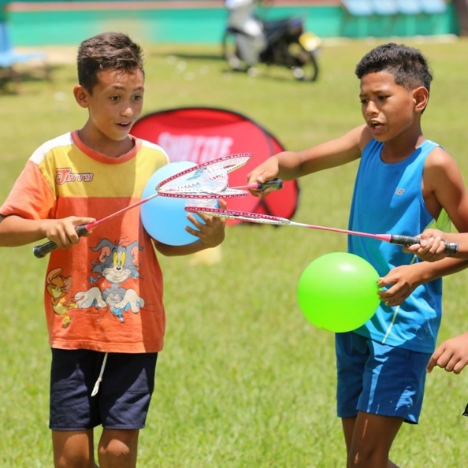
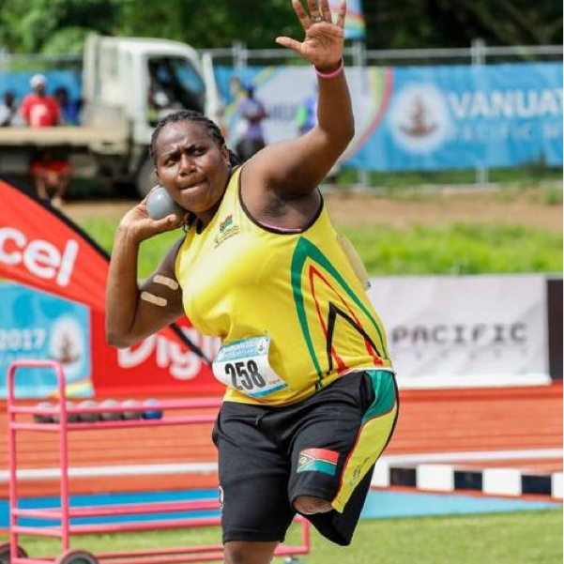
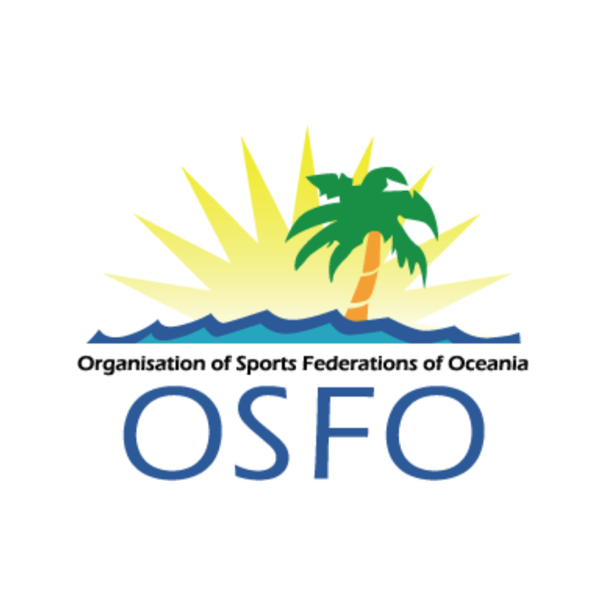
“The leading advocate for inclusive collaboration across all sports in Oceania”
OSFO Vision
PROSPECTUS

Organisation of Sports Federations of Oceania

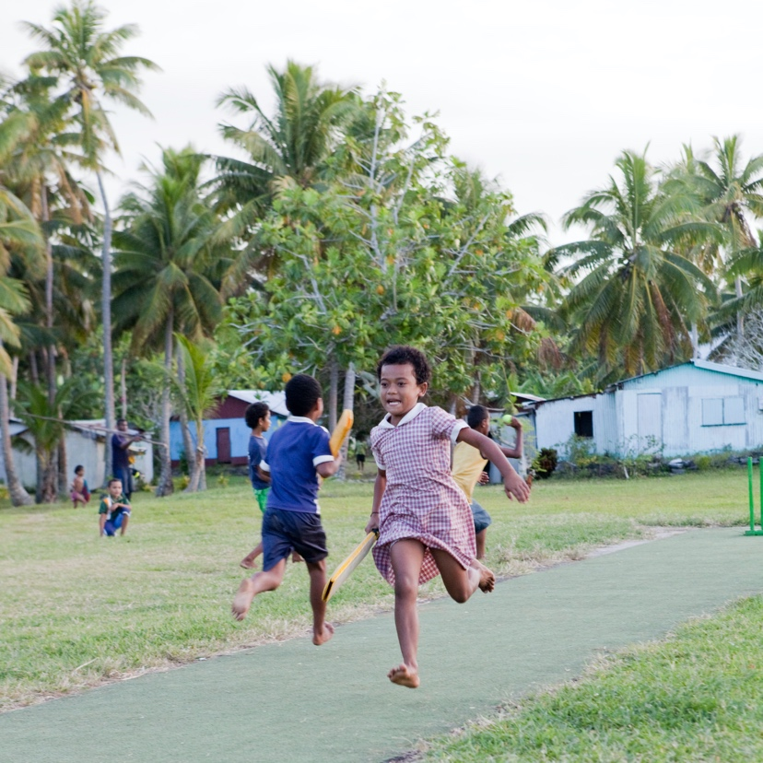
- INTEGRITY - modelling high levels of honesty, accountability, transparency and ethical behaviour creating an environment of mutual trust and respect
- LEADERSHIP - as the peak body representing sport to key decision-making bodies, empowering all stakeholders to improve outcomes for athletes and lift the profile of sport and its benefits
- INCLUSION - embracing diversity and inclusivity, providing accessible and equitable opportunities, appreciating cultures of our region
- COLLABORATION - providing a co-operative network and advocacy service to build a united voice for the community of sport

OSFO OPERATES WITH:
- To Lead, Sustain, Develop and Advocate an enabling environment that assists our Members to enhance the role of sport

OSFO
Mission
Organisation of Sports Federations of Oceania
P. 02
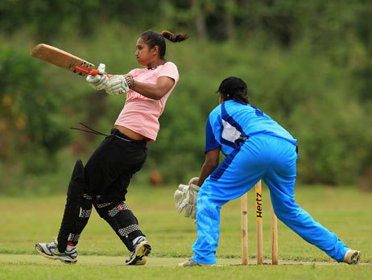
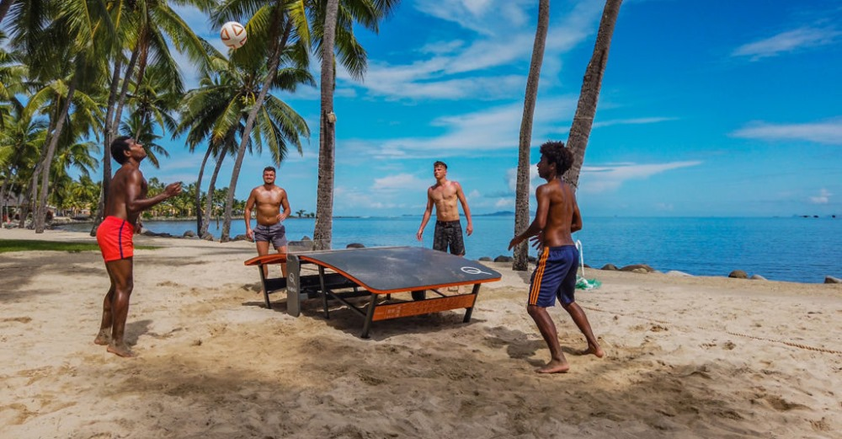
TABLE OF CONTENTS
02. OSFO MISSION / OPERATES WITH:
07. OSFO MEMBERS

04. ROLES AND RESPONSIBILITIES
OF INTERNATIONAL FEDERATIONS
06. OSFO MEMBER BENEFITS - FUTURE

05. OSFO MEMBER BENEFITS - CURRENT
03. TABLE OF CONTENTS
Organisation of Sports Federations of Oceania
P. 03
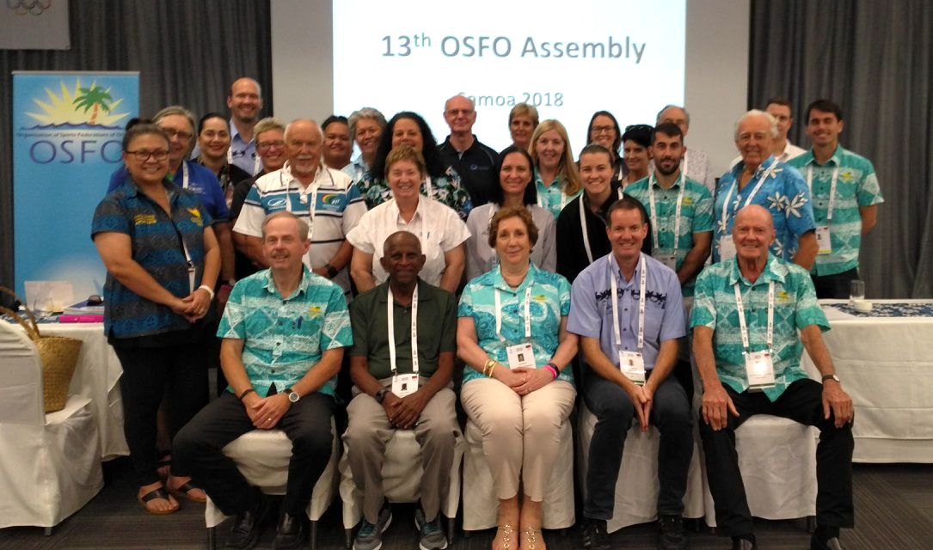
Organisation of Sports Federations of Oceania
Officially, OSFO was established in Brisbane in March 2005. At a meeting attended by 14 regional sports federations, it was decided that an official body should be formed to represent the interests of the members in the region. A Constitution was passed, membership criteria established, and a commitment made to meeting annually during the ONOC Annual Assembly.
OSFO aims to unite regional sports federations to:
- Promote sport in the Pacific.
- Protect common interests.
- Cooperate together to share knowledge and resources.
- Coordinate development to maximize the cost-effective use of resources.
- Collect and distribute relevant information.
- Support one another and respective activities.
- Maintain the authority and autonomy of members.

OSFO operates with the following objectives:
- OSFO exists to represent the interests of member to ONOC, the IOC, governments, and any other organisation that may impact the delivery of the services of the members’ international federations.
- OSFO exists to foster participation in sporting activities within the Oceania region.
- OSFO will foster the development of sporting excellence throughout the Oceania region.
- OSFO will foster communication between international federations that operate in the Oceania region and with any other organisation responsible for the delivery of sports development and advancement in the region.
- OSFO will establish cooperative relations with all such other organisations with similar objectives to its own.
- OSFO will carry out its objectives without political, religious, cultural or gender bias.
- OSFO will foster the establishment of organisations representing all the international federations that operate in the region.

About
Us
P. 04
Organisation of Sports Federations of Oceania
Organisation:
- Organisation of large regional, continental and world competitions;
- Control of all international competitions;
- Training and accreditation of international referees;
- Coordination of the activities of their members.
For each of the sports included in the programme of the Olympic Games, the technical preparation and actual running of the competitions during the Games are the responsibility of the International Federations governing the sport in question.
Development of the Sports Movement:
The International Federations make an essential contribution to the development of sport through the contributions and the cooperation of the National Federations affiliated to them.
Following the statement from the Tripartite Commission of the IOC in 1978, the responsibilities of International Federations (IFs) cover the legislation, organisation and development of sport. OSFO supports the Oceania IFs in these functions within the Oceania region:
Legislation:
- Promulgation of regulations governing the practice of the sport concerned, the installations and equipment, the length of events and the rules governing them;
- Classification of competitors into categories according to sex, age, weight and performance
- Definition of the competitor’s status (e.g. amateur, professional);
- Laying down of medical riles aimed at protecting the health of athletes while fighting against doping and other dangerous practices;
- Adoption of preventative measures against all unfair and unlawful dealings.
Roles and Responsibilities
of International Federations
P. 05
Projects Duration
Four Weeks

Project Stage
Website Design
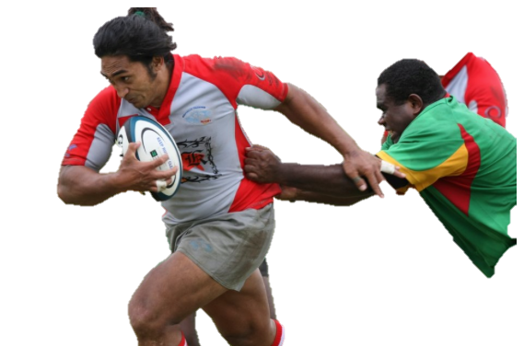
Organisation of Sports Federations of Oceania
- Affiliation with a professional body that has been working in the Oceania sporting industry since 2006.
- The benefits of coordination and cooperation in sports federation programs throughout the Oceania region.
- Opportunities for collaboration and consultation when formulating strategic plans within the region.
- Promoting member sports’ activities in the region on the OSFO website, social media and other digital communication channels.
- Quarterly newsletter with relevant industry updates, as well as the opportunity to support your sports’ programs and activities in the same publication.
- The opportunity to nominate and be nominated for the OSFO Merit Award.
- Advocacy: ‘one voice’ for sports in the region.
- Education and training of coaches and officials through the Oceania Sports Education Program (OSEP).
- Advice, guidance and support to all member sports on a wide range of topics.
- Access to athlete wellbeing and engagement programs within the region.
- Opportunities for mentoring of athletes, administrators and coaches.
- Access to the Positive Edge Journal.
- Assistance in seeking and applying for additional funding available to sports federations.
- Promotions about events from the Pacific Games through to regional competitive events, as well as benchmark international competitions such as World Championships and the Olympic and Commonwealth Games.
- Support surrounding the initiative of the continual absorption of Australia and New Zealand competitions at the Pacific Games.
- Regular communication with fellow member sports federations.
- Annual invitation to the OSFO AGM and General Assembly, including workshops run by both ONOC and the Pacific Games Council.
OSFO MEMBER BENEFITS
Currently OSFO Members receive
P. 06

P. 07
Organisation of Sports Federations of Oceania
Designsoul
P. 13
Quote
Breakdown
Description

Umlauted labored auto volutes autism dolumqui is deplore bolero opmagnietur
Valero magneto, vquiaut editing elemis vendignate ipsum facequo..
Labored ores bolero assume voluptaquunt rem eturaut
Branding Identity Design & Prototype
Amount
10 Days
$3,500
Digital Photography & Testing
Web Design & Promotion
Umlauted labored auto volutes autism dolumqui is deplore bolero opmagnietur
Valero magneto, vquiaut editing elemis vendignate ipsum facequo..
Labored ores bolero assume voluptaquunt rem eturaut
Umlauted labored auto volutes autism dolumqui is deplore bolero opmagnietur
Valero magneto, vquiaut editing elemis vendignate ipsum facequo..
Labored ores bolero assume voluptaquunt rem eturaut
Total

15 Days
$5,000
30 Days
$6,500
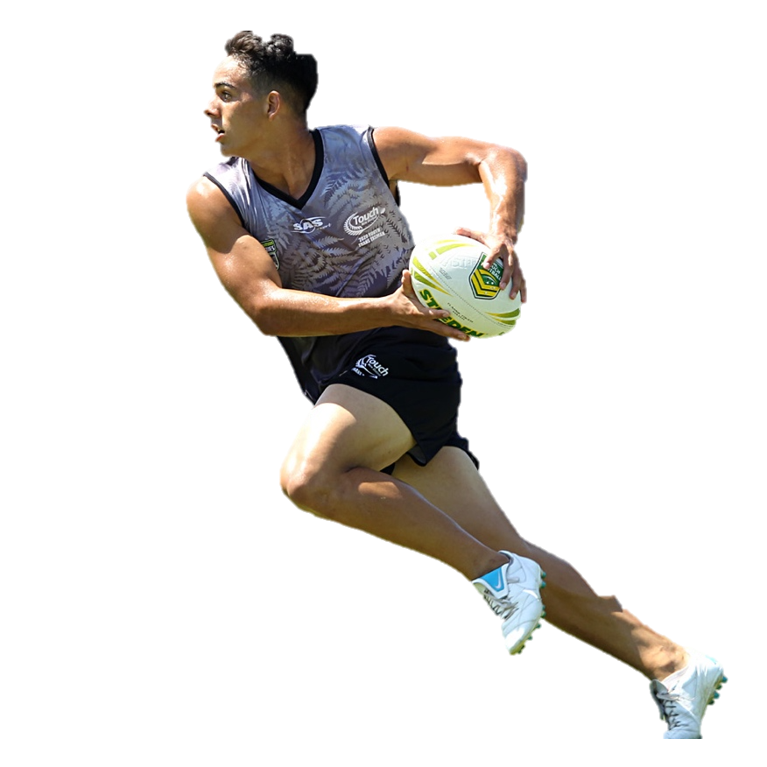
- Membership certification / recognition program.
- Bulk buying power opportunities (e.g. insurance).
- Access to best-practice templates for various governance and operational.
Future benefits that OSFO are working on introducing for Members
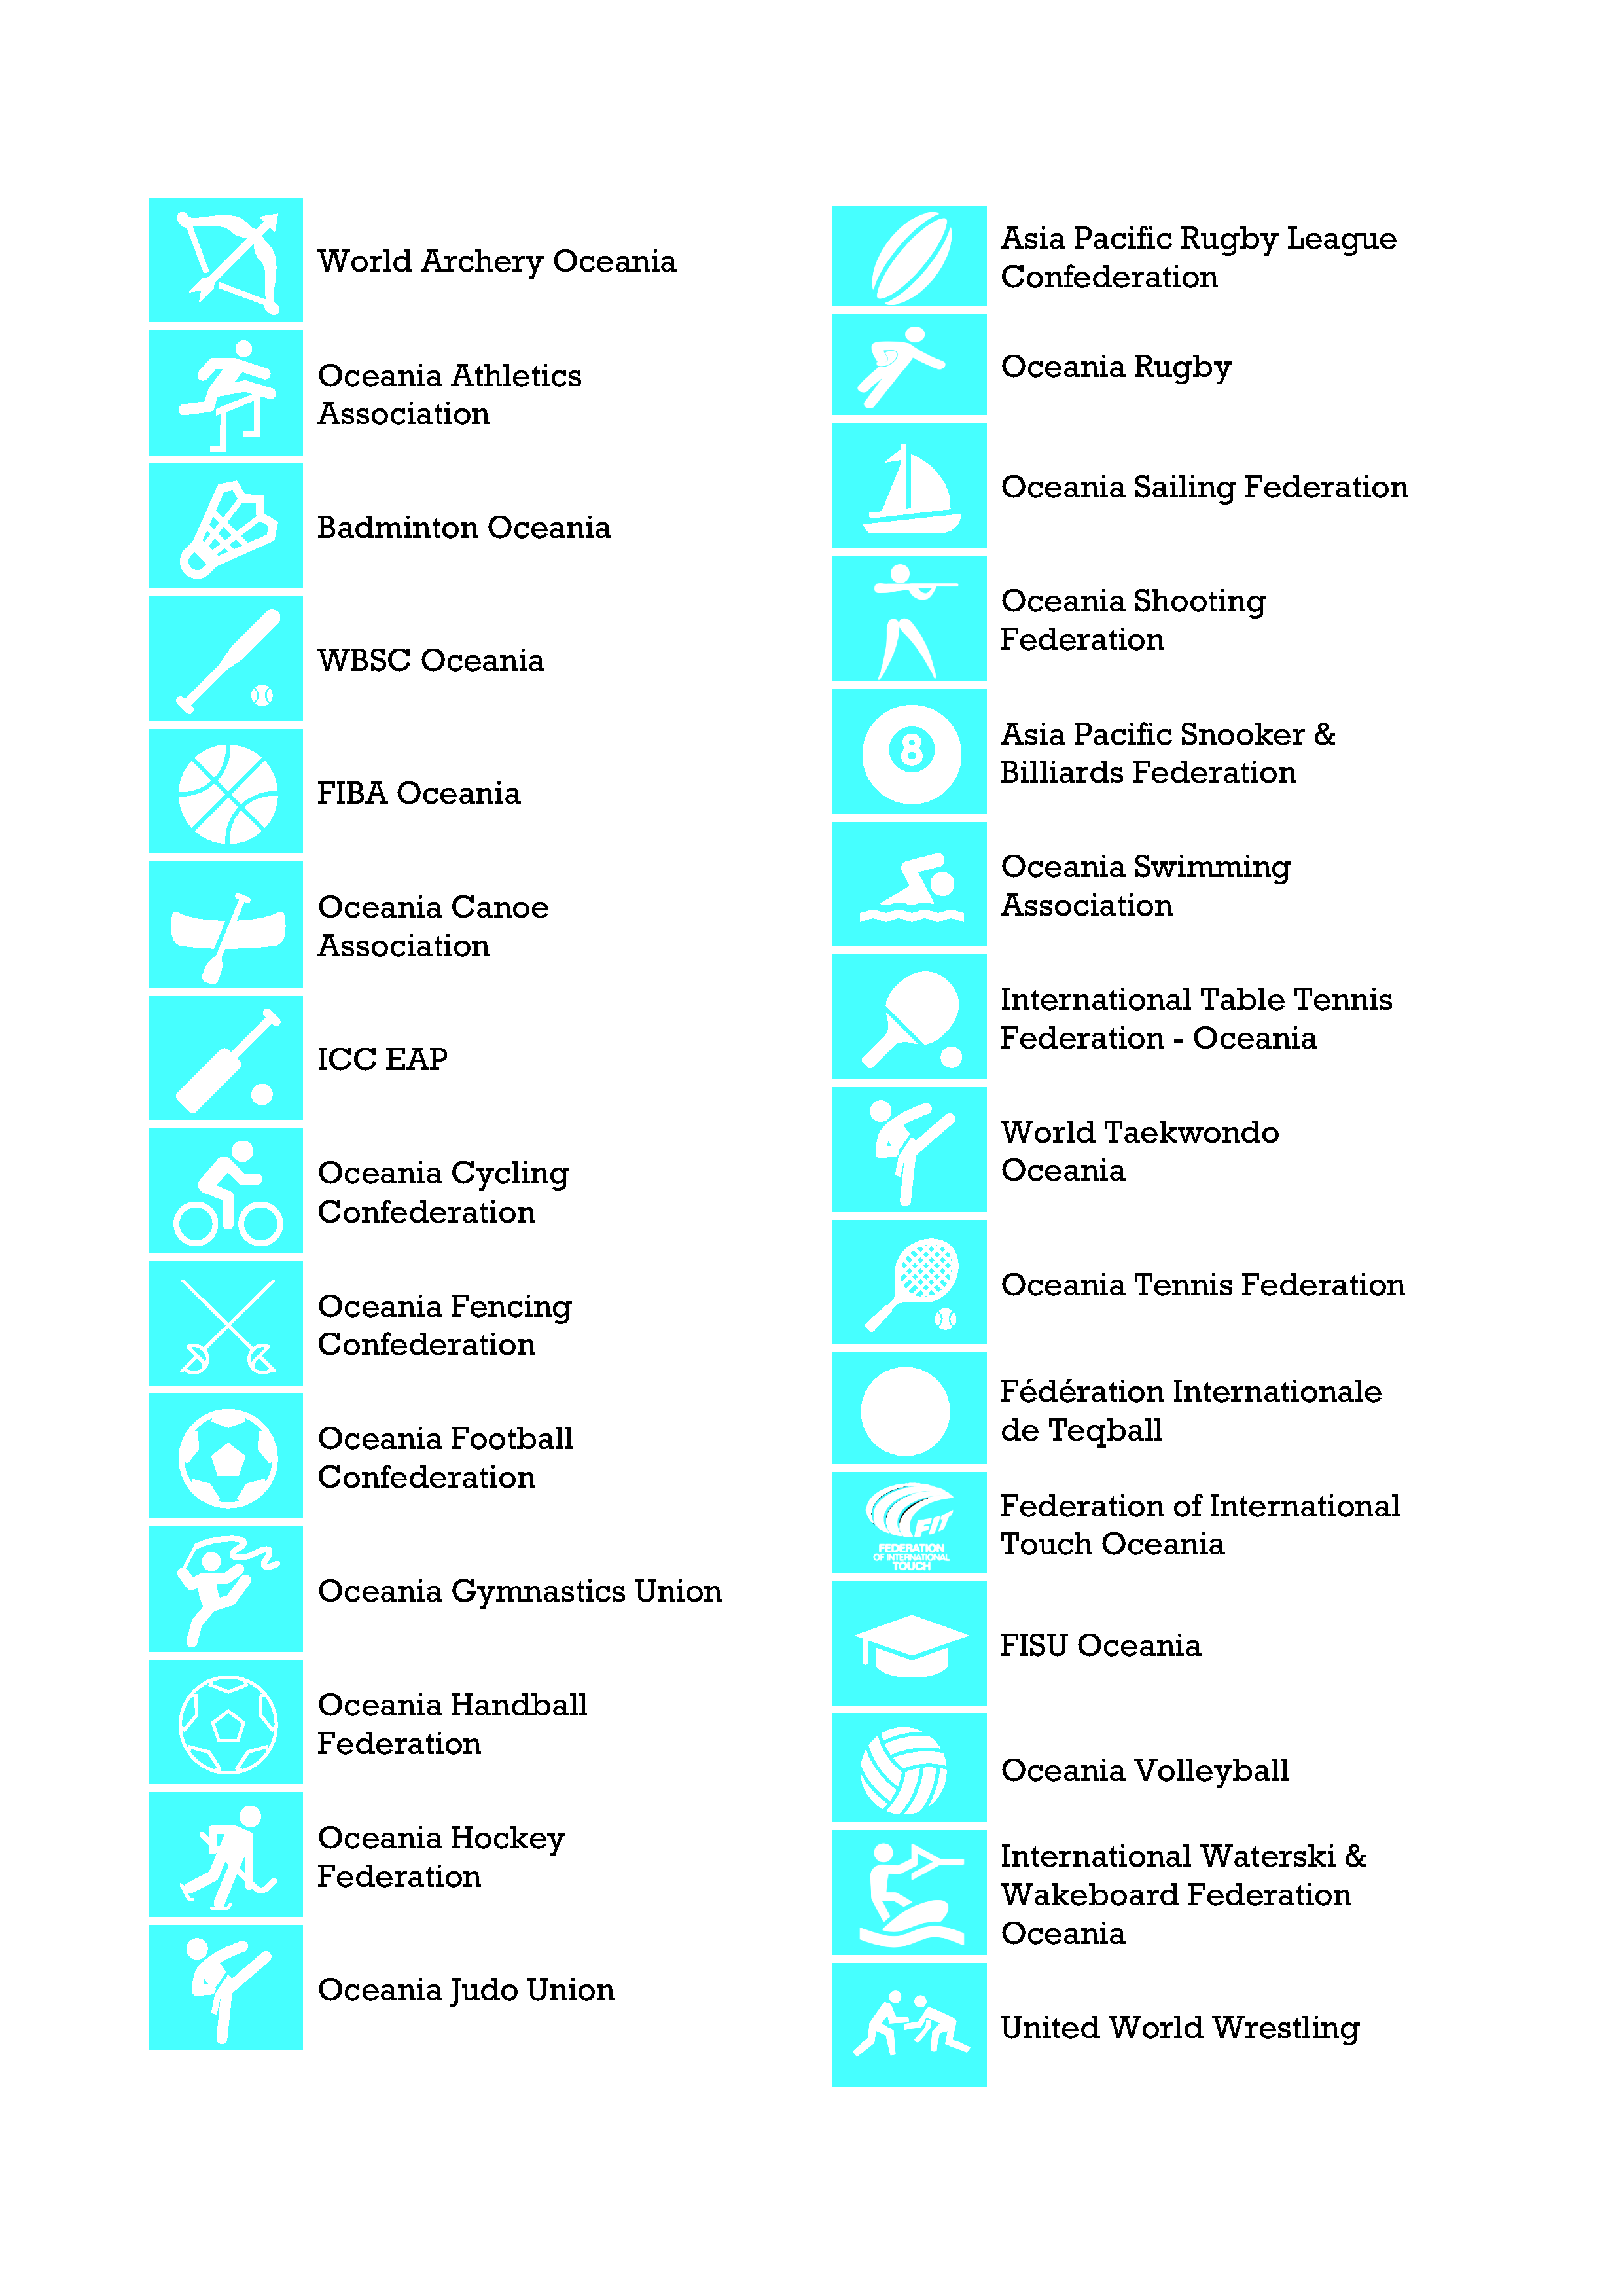
Organisation of Sports Federations of Oceania
CURRENT OSFO MEMBERS

